**Le sport mots croisés n°1**

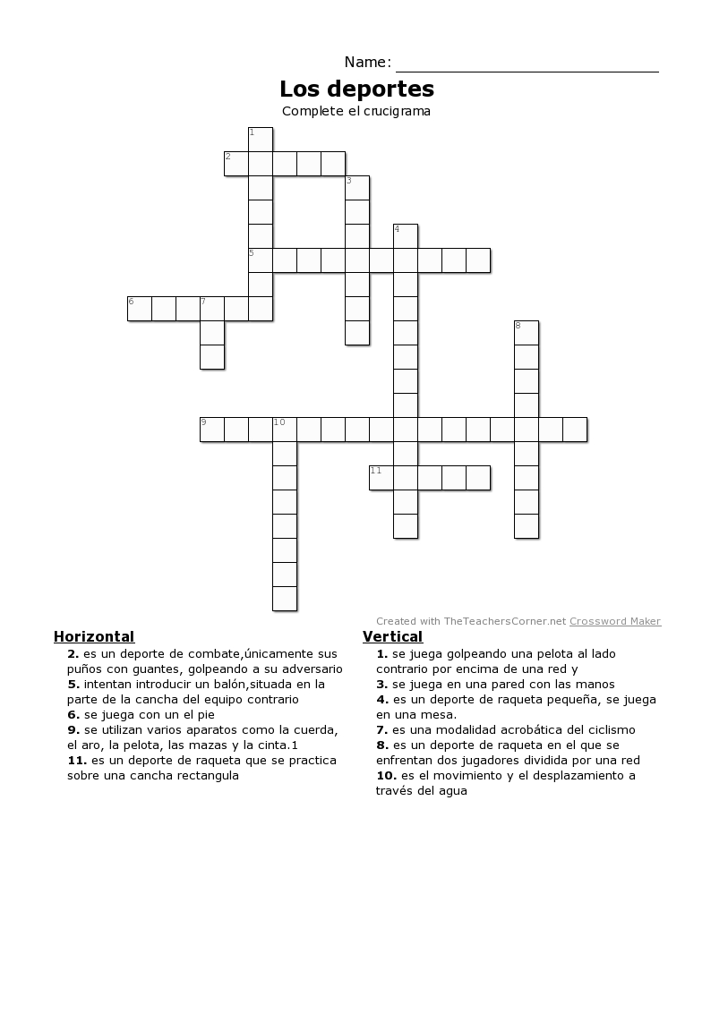

**Le sport mots croisés n°2**

